Please note the plant Digitalis purpurea (the foxglove) has had to be replaced by the plant Hordeum vulgare (barley) for this practical in Semester 2 2025.

Acclimation to Sun and Shade in Digitalis purpurea.
Background: Plants need light to grow. Light energy is absorbed by chlorophyll, which absorbs blue and red wavelengths of light (giving leaves a green colour). Absorbed light energy is used to drive an electron transport chain (see How to Grow a Planet, Week 1), with the energy driving the production of sugars that support growth. Plants contain two forms of chlorophyll – chlorophyll a and b, which absorb slightly different wavelengths.
In nature, plants compete for light along with other resources. To optimise their light capture, they change both their morphology (arrangement of leave, height, leaf thickness etc.) and their biochemistry, including changing their chlorophyll content.
In this experiment you will examine the response of a plant species to growth in sun vs shade
Study species: the plant you will examine is Digitalis purpurea, the foxglove. This species is native to woodland margins and clearing and hedgerows (Johnson et al. 1993). As such it is adapted to grow in a range of different light conditions. When it grows in different conditions, it will acclimate to those conditions (Gjindali and Johnson 2023).
Adaptation – a genetic difference between individuals or species that makes them better able to survive in particular conditions
Acclimation- a change in the phenotype of an organism in response to the environment in which it develops
Aims: In this experiment, you will examine the morphology and the chlorophyll content of D. purpurea grown in either sun or shade.
Each pair of students is provided with 2 plants – one from sun and one from shade.
- Examine the two plants. Note their appearance, how do they look different? Remove the largest leaf from each plant, cutting it as close to the ground as possible. Measure the length of the petiole (the leaf stalk).
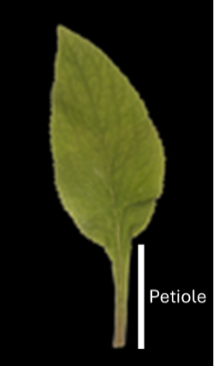
Figure 1 A foxglove leaf
……………………………………………………………………………………..
……………………………………………………………………………………..
……………………………………………………………………………………..
……………………………………………………………………………………..
……………………………………………………………………………………..
Petiole Length: ………………………………………………………………..
Photo: Pipi69e, Public domain,
via Wikimedia Commons
- Cut a square from each leaf, approx. 2cm x 2cm. Measure the area of this by placing it on a piece of graph paper and carefully drawing round the perimeter. You can estimate the area by counting the number of mm squares inside the leaf image.
Leaf area sun: ……………………………………………………………………………………..
Leaf area shade: ……………………………………………………………………………………..
- Weigh the leaf pieces using a fine balance and then calculate the leaf weight ratio (weight/area)

Weight sun ………………………………………………………………………………..
Weight shade ………………………………………………………………………………..
Leaf weight ratio sun: ………………………………………………………………………………..
Leaf weight ratio shade: ………………………………………………………………………………..
If these values are different, why do you think this is?
………………………………………………………………………………..…………………………………
……………………………………………..……………………………………………………………………
- You will now extract the chlorophyll from the leaf pieces.
  - Take one leaf piece and place it in the mortar.
  - Using a Pasteur pipette, add 3-4 drops of 96% ethanol.
  - Using a pestle, grind the leaf as completely as possible. This should result in a green smear on the bottom of the pestle.
  - Add a few more drops of ethanol. Stir with the pestle to produce a uniform green solution, without any leaf pieces in it.
  - Using a new Pasteur pipette transfer the green liquid to a measuring cylinder. (IMPORTANT: make sure you do not mix up the pipettes, you must avoid getting chlorophyll into your clean ethanol stock!)
  - Wash the mortar with a little more ethanol, and transfer this into the measuring cylinder
  - Add more ethanol to make the volume in the measuring cylinder up to 10ml.
  - Cover the measuring cylinder with parafilm and mix carefully.

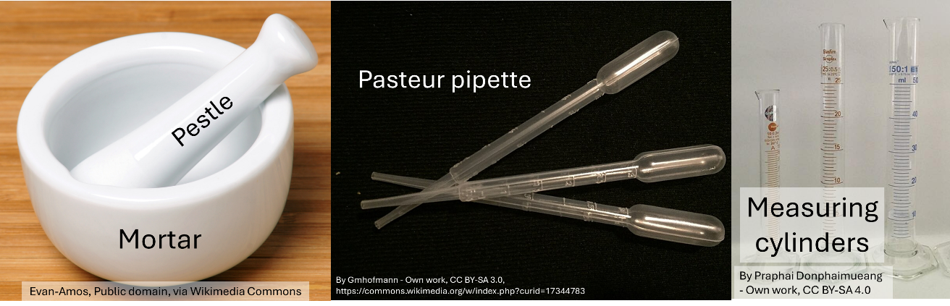
Fig. 2 Equipment used in this experiment
- Filter the chlorophyll solutions.
  - Take a piece of filter paper and fold it into quarters (in half and then in half again).
  - Open up the folded triangle to form a cone and the place it into a filter funnel
  - Place the filter funnel into a beaker, tip down
  - Pour the chlorophyll extract into the filter funnel, making sure that it all goes into the filter paper and does not go over the top

- Measure the absorbance of the solution at 665 nm, 649 nm and at 750 nm
  - Take 3 cuvettes. Carefully fill one with clean ethanol. Place your two chlorophyll extracts into the other two. Be careful to remember which is which and be careful not to touch the sides of the cuvette with your fingers.
  - Set the wavelength of the spectrophotometer to 665 nm
  - Place the clean ethanol cuvette into the spectrophotometer.
  - Press the Zero button to zero the spectrophotometer.
  - Place each of the cuvettes with your extracts in the spectrophotometer and record the absorbance value for each (n.b. depending on the spectrophotometer you are using, you may be able to place all cuvettes in the spectrophotometer and switch easily between them).
  - Change the wavelength to 649 nm and repeat steps c-e
  - Change the wavelength to 750 nm and repeat steps c-e.
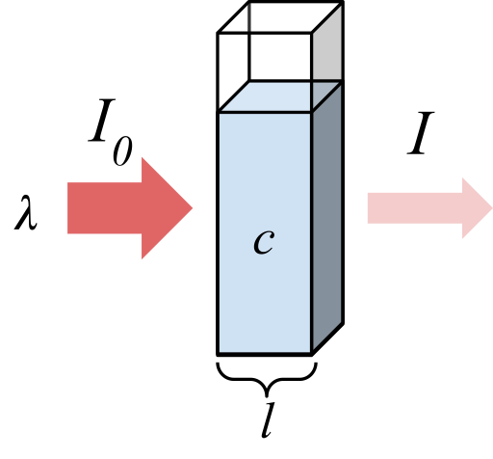
Figure 3: diagram of a cuvette with light passing through. Marmot2019, CC BY-SA 4.0 via Wikimedia Commons

What is absorbance? Absorbance is a measure of how much light at a particular wavelength passes through a solution. Absorbance (A) is defined as:
$$A=log⁡(\frac{I_{t}}{I_{0}})$$
Where I₀ is the light incident on the solution and I_{t} is the light passing through the solution. (When we measure in a spectrophotometer, I₀ is the light passing through the reference sample, in this case clean ethanol).
The amount of light absorbed by a solution is proportional to the concentration of the absorbing molecule. This relationship depends on the extinction coefficient (ε), according to the equation:
$$A=ε.c.d$$
Where A is absorbance, ε is the extinction coefficient and d is the distance through which the light passes (the length of the cuvette). This is called the Beer-Lambert Law (Rodger 2013). Usually we use a 1cm cuvette, meaning that the length term can be ignored.
For any light-absorbing molecule, in a given solvent, we can measure the extinction coefficient for each wavelength. In our experiment, we are measuring absorbance of two forms of chlorophyll, each having overlapping spectra. They both absorb light at 665 nm and at 649 nm, but they have different extinction coefficients at each wavelength. We can therefore use simultaneous to calculate the concentration of each chlorophyll in our mixed solution. Neither molecule absorbs at 750 nm, so why do we measure at this wavelength?
- Calculate the concentrations of chlorophyll a and b in each of your extracts using the following equations:

Chlorophyll a = 13.95.(A₆₆₅-A₇₅₀) – 6.88.(A₆₄₉-A₇₅₀) μg.ml⁻¹
Chlorophyll b = 24.96. (A₆₄₉-A₇₅₀) – 7.32. (A₆₆₅-A₇₅₀) μg.ml⁻¹
(Lichtenthaler and Wellburn 1983)
- Knowing the concentration of chlorophyll a and b in your extracts, the volume of extract you made and the amount of leaf you used, you can now calculate the concentration inside your leaf pieces. You can express this per unit area of leaf and per unit weight of leaf:

Analysing and presenting your data: Having collected data about your sun and shade plants, you now need to use statistics to compare the values measured and produce some figures to describe what you have seen. Given that biological parameters are variable and that you can never measure them perfectly, you need more than one estimate of each parameter to have confidence in the values you have measured and be able to conclude whether they change between sun and shade. You should therefore collect data from at least 4 other pairs of students. You can then calculate means and standard errors for each of the parameters measured. Plot graphs to show the values of petiole length, leaf weight ratio, total chlorophyll (a+b) per unit area, total chlorophyll per unit weight and chlorophyll a/b. You also need to use a statistical test to determine whether the values recorded vary significantly. Graph plotting and statistical test can be carried out using software such as R studio or GraphPad Prism

What statistical test could you use to compare two numerical values (assuming they are normally distributed)? …………………………………………………………………………………………

Interpreting your data: Having completed your experiment, you now need to consider what the results mean. Questions you need to consider include:
- Are the petiole different lengths between plants. If so, why might this be the case?
- Does the leaf weight ratio differ between sun and shade plants? What does this tell you about the leaf structure?
- How does the total chlorophyll vary between plants, expressed per unit area and weight? What do these two different ways of expressing the data tell you?
- Does the chlorophyll a/b ratio vary depending on growth conditions? How might varying the relative amount of these pigments be of benefit to plants?

References:
Gjindali A, Johnson GN (2023) Photosynthetic acclimation to changing environments. Biochem Soc Trans 51 (2):473-486. doi:10.1042/bst20211245
Johnson GN, Scholes JD, Horton P, Young AJ (1993) Relationships Between Carotenoid Composition and Growth Habit in British Plant-Species. Plant Cell Environ 16 (6):681-686. doi:10.1111/j.1365-3040.1993.tb00486.x
Lichtenthaler HK, Wellburn AR (1983) Determinations of total carotenoids and chlorophylls a and b of leaf extracts in different solvents. Biochem Soc Trans 11 (5):591-592. doi:10.1042/bst0110591
Rodger A (2013) Concentration Determination Using Beer-Lambert Law. In: Roberts GCK (ed) Encyclopedia of Biophysics. Springer Berlin Heidelberg, Berlin, Heidelberg, pp 360-361. doi:10.1007/978-3-642-16712-6_775

